

Mathematics Specialist Unit 1

Test 1b

Vectors

Name: ______________________ Total Marks:__________

Task type: Response

Time allowed for this task: 40 minutes, in-class, under test conditions

Reading time: 3 minutes
Working time: 37 minutes

Materials required: Calculator with CAS capability (to be provided by the student)

Standard items: Pens (blue/black preferred), pencils (including coloured), sharpener, correction fluid/tape, eraser, ruler, highlighters

Special items: Drawing instruments, templates, notes on two unfolded sheets of
A4 paper, and up to three calculators approved for use in the WACE examinations

Marks available: 37 marks

Task weighting: 4.5%

Question 1 [3 marks]

Given a = 14i + 11j and b = 6i + kj, find the values of k such that│a│= 2│b│.

Question 2 [4, 3 marks]

a) On the grid below, show the location of the points A to E given that:
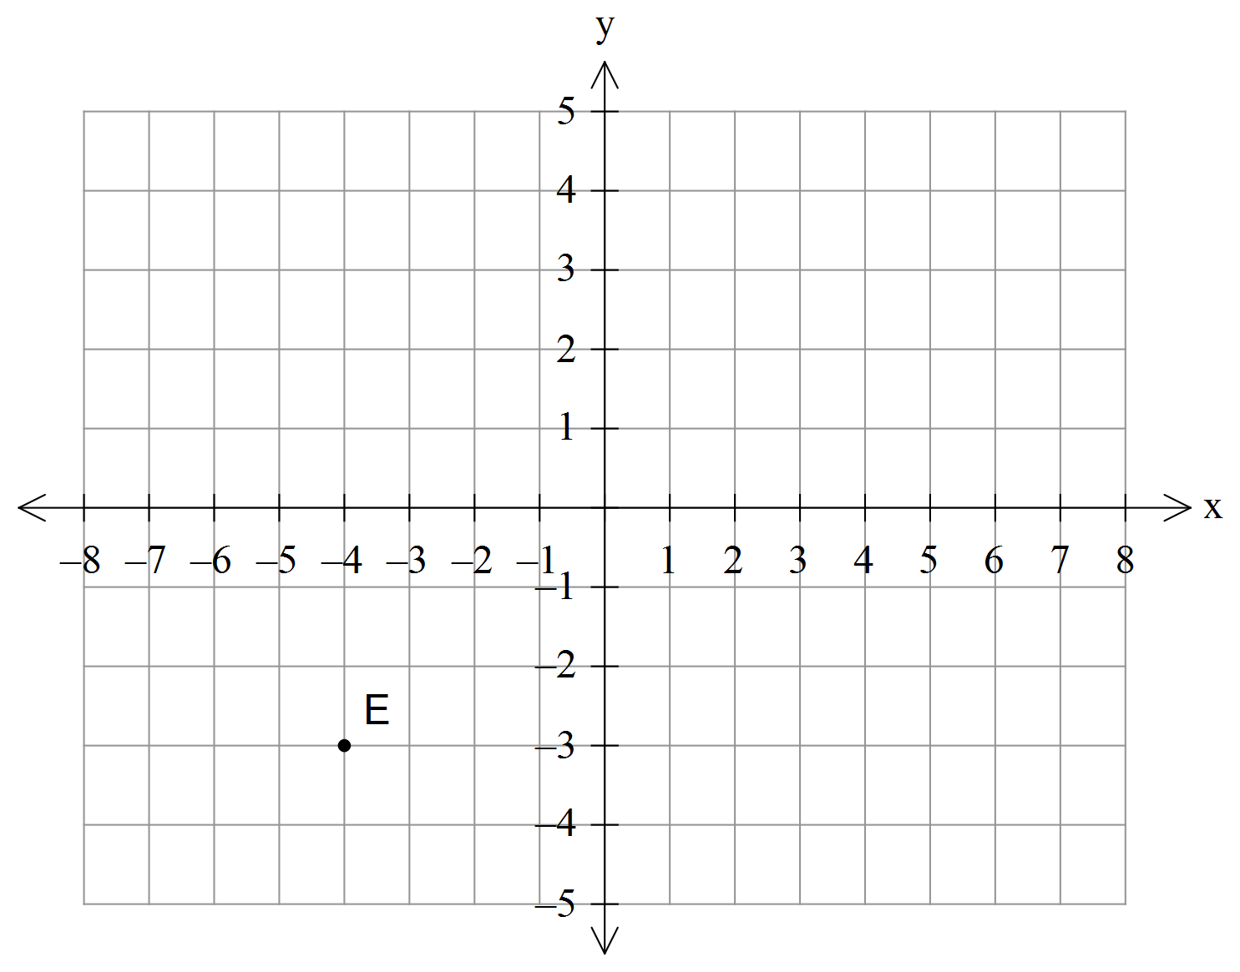[4]

_{C}r_{A} = i – 2j
r_{B} = 4i - 3j
_{C}r_{D} = -i + 2j
_{A}r_{E} = 3i + 4j

b) Ship A has position vector (12i – 6j) km. Relative to an observer on ship B, ship A has position vector
(8i – 8j) km. How far is ship B from the origin? [3]

Question 3 [3, 3, 3, 3 marks]

If A(7, -10), B(-5, 6), C(-8, 10) and $D(3, k):$

- Find the unit vector parallel to$\vec{ BC}$.

- Show, using vectors, that A, B and C are collinear (i.e. in a line).

- Find the value of k given that $\vec{BC}$ is perpendicular to $\vec{BD}$

- Find a point P such that P divides $\vec{AC}$ in the ratio 3:1. (Show full working).

Question 4 [1, 1, 3, 3 marks]
- Use the scalar product to show that
  - The vectors $(4, -6)$ and $\left(3, 2\right)$ are perpendicular.

  - The vectors $\left[\begin{matrix}-1 \\ 3\end{matrix}\right]$and $\left[\begin{matrix}0.5 \\ -1.5\end{matrix}\right]$ are parallel.

- Find the size of the angle between 12i – 5j and -8i + j.

- Determine the vector projection of $3i-j$ onto $-4i+3j$.

Question 5 [4 marks]

To Jason who is jogging due East at 8km/h, the wind seems to come from the South with a speed of 5km/h. Find the true magnitude and direction from which the wind is blowing.

Question 6 [3 marks]
Relative to a city, a harbour has a position of $<-21, 63>$while a lighthouse relative to the city has position
$<2, 17>.$ A fishing boat travels between the harbour and lighthouse at 16km/h. Find the time it takes for this journey.

